**OPRAH WINFREY**

**Oprah Gail Winfrey (n Kosciusko, Mississippi;. January 29, 1954) is a TV presenter, producer, actress, businesswoman, philanthropist and critic of American books.**

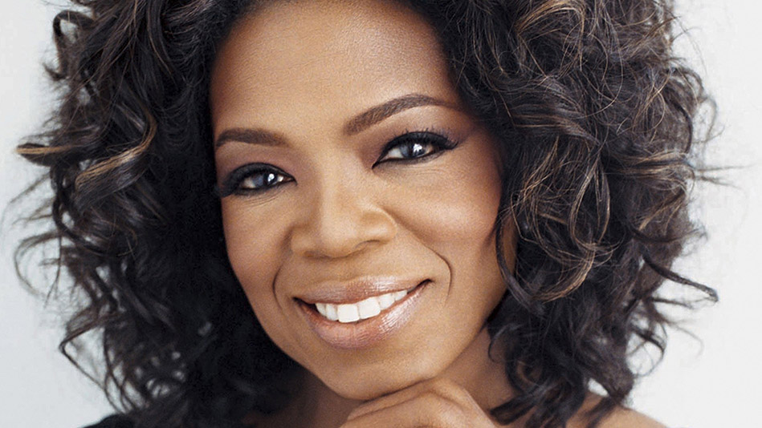

**He was born of a single mother from rural poverty in Mississippi and was later raised in an inner city of the country, Milwaukee. She described herself as a promiscuous teenage victim of sexual abuse and rape, giving birth at age 14 to a premature child who dies shortly after.**

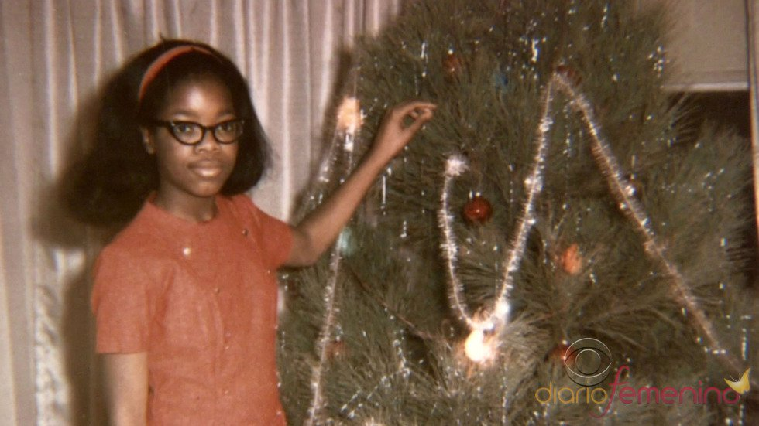

**It was several times Emmy Award winner for his show The Oprah Winfrey Show, the most watched talk show in the history of television. also an influential book critic, an actress nominated for an Academy Award, and editor of his own magazine.**

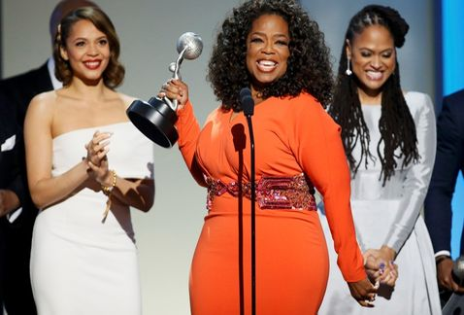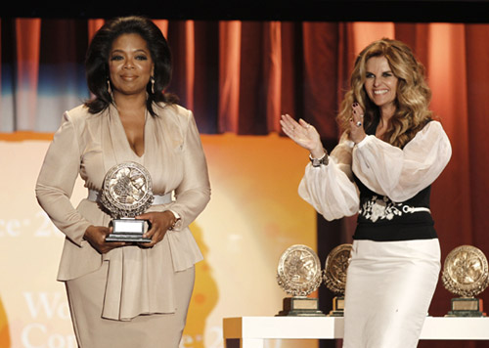

**Life magazine has called the most influential woman of her generation and Time magazine has named her one of the four people who have shaped the twentieth century and the beginning of the century.**

**In 2013, he received the Presidential Medal of Freedom, the highest civilian honor in the United States.**

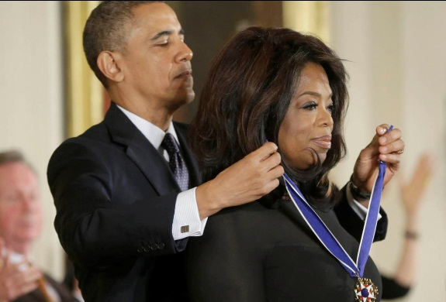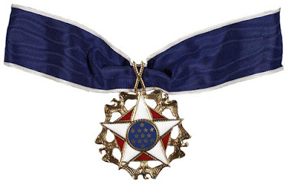

**The most important interviews that Oprah has made are:**

**• With Michael Jackson:**

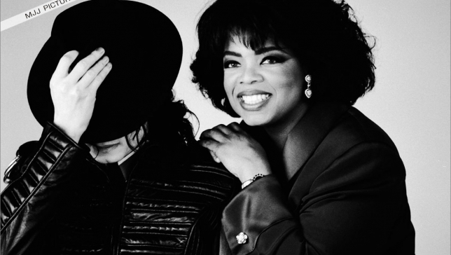

* **With Elizabeth Taylor:**

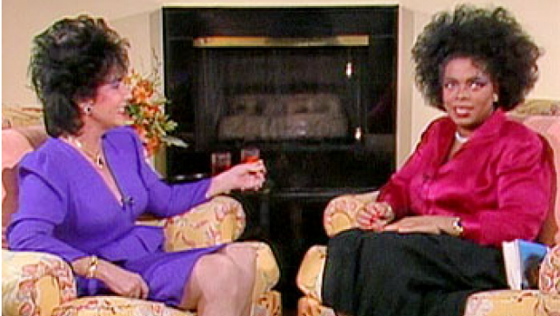

* **With Tom Cruise:**

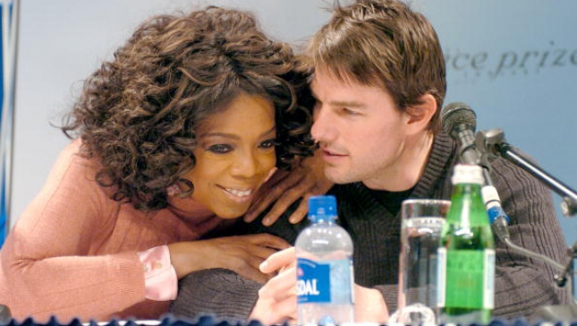

* **With Celine Dion:**

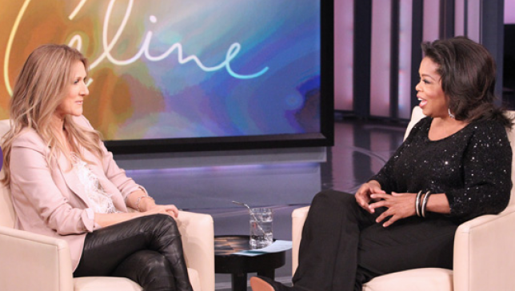

* **With Justin Bieber:**

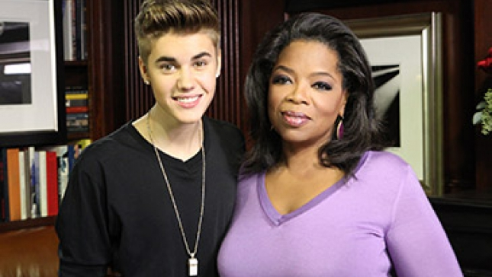

* **With Hugh Jackman:**

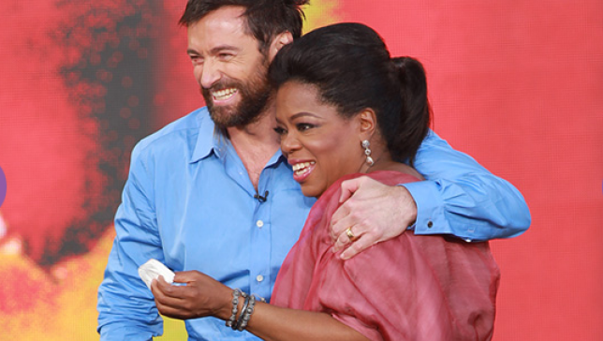

* **With Withney Houston:**

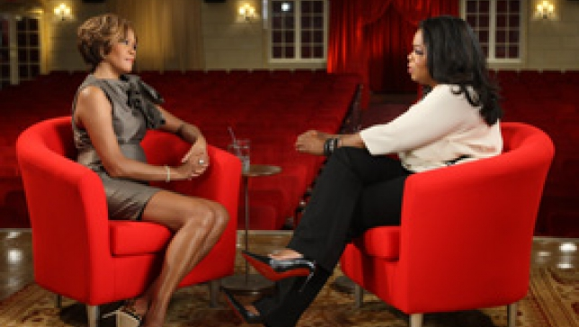

* **With Obama’s Family:**

